**DATA VISUALIZATION 44613**

**MODULE 7 FINAL PROJECT:**

**TOPIC:** **SPOTIFY UNPOPULAR SONGS ANALYSIS**

**RAMON TORRES**

**MODULE 7 FINAL PROJECT PLANNING PROCESS**

**Project scope:** The final project will inspect a Spotify songs data set. The exploratory methodology of this secondary data set will identify the main factors that describe unpopular songs, currently available on Spotify. Therefore, evaluating the factor driving customers away from listening. For this final project six factors were selected songs energy levels, loudness, speech or vocals, no vocals or instrumentals, liveness, and duration. These factors will be compared against the popularity levels, as described by the users. In addition, it may assist in determining which songs are not selected by music enthusiastic due to several factors, making these songs unlikeable. This will certainly assist the Spotify algorithm to better evaluate the user experience and design an optimize recommended listening playlist for each user and keep them engaged on the application a longer period.

**Project tasks:**

a. Determining final project tasks, planning and final project timeline was provided in the instructions of this homework.

b. Search for sources of datasets on the web

c. Examine and review the data sets attributes, rows and columns.

d. Define final project scope.

e. Download and store data set file.

f. Cleaning and deletion of blanks spaces, rows, or columns on the selected data set

g. Review headings, titles, and data formats

h. Transposing the data, if required

i. Deletion of segmented data, if required

j. Conversion of CSV file to MS Excel format

k. Write the six required goals for the project.

l. Connect MS Excel in Tableau

m. Define and review necessary working worksheets on Tableau.

n. Generate the necessary charts and specs on Tableau.

o. Write and summarize a story for each goal chart and specs on Tableau.

p. Generate the required storyboards and dashboards on Tableau.

q. Review headings, titles, and data formats

r. Review the entire project for errors, comments, and summary.

s. Zip the appropriate files as required for this project.

t. Submit final project via CANVAS.

**Module 7 Learning outcomes:**

MO 1 Recognize the types of data visualization (CO 2, 3, 6)

MO 2 Identify the tools & techniques used for extraction & cleaning of data (CO 2, 3)

MO 3 Identify the most appropriate visualization method for a given type of data and task (CO 2, 3, 6, 7)

MO 4 Create interactive dashboards and data stories using tableau (CO 3, 4, 5)

**Instructions:**

1. Ensure to include your full name: **Ramón Torres**
2. Search and select the interested and exciting data: Spotify unpopular songs, **Source Kaggle:**

<https://www.kaggle.com/datasets/estienneggx/spotify-unpopular-songs>

1. Write the goals related to your dataset. The total number of goals must be a minimum of 6
2. Clean the data such that it addresses your goals
3. Your solution should contain appropriate charts for the proposed goals. You can visualize more than one chart for one goal
4. Select tools to visualize the charts. You may use multiple tools for your project. Ex: Excel and/or Tableau
5. Write stories for your visualizations
6. Your submission should be a Microsoft Word document. This should include the following:

**MODULE 7 FINAL PROJECT CONTENT**

**TOPIC: SPOTIFY UNPOPULAR SONGS ANALYSIS**

* 1. Write a brief introduction of your project:

**The final project will inspect a Spotify songs data set. The exploratory methodology of this secondary data set will identify the main factors that describe unpopular songs, currently available on Spotify. Therefore, evaluating the factor driving customers away from listening. For this final project six factors were selected songs energy levels, loudness, speech or vocals, no vocals or instrumentals, liveness, and duration. These factors will be compared against the popularity levels, as described by the users. In addition, it may assist in determining which songs are not selected by music enthusiastic due to several factors, making these songs unlikeable. This will certainly assist the Spotify algorithm to better evaluate the user experience and design an optimize recommended listening playlist for each user and keep them engage on the application a longer period.**

* 1. The domain of the data set: **Source CSV files from Kaggle Datasets**

<https://www.kaggle.com/datasets/estienneggx/spotify-unpopular-songs>

* 1. The data file:



* 1. Data source

<https://www.kaggle.com/datasets/estienneggx/spotify-unpopular-songs>

* 1. Number of records and columns:

**Records = 4074-1=4073 , Columns = 17**

**Image 1, Sample of columns description and trend analysis for each column**

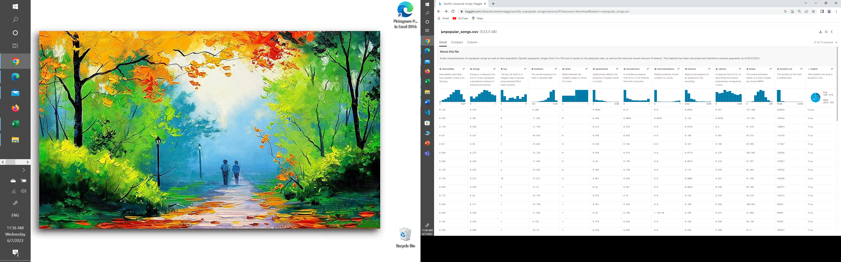

* 1. Visualization tools selected:

**MS Excel for data conversion from a CSV to a MS Excel format to make available for Tableau. In addition, for data cleaning for incomplete records and chart modelling. Tableau for data visualization and dashboard representations.**

* 1. Data cleaning strategies if any

**Summary: Data cleaning provide guarantees on the data analytics processes. Cleansing produces consistent, structured, accurate data, which allows for informed, intelligent decisions. As analyses and algorithms are only as good as the data they are based on data cleaning presents enormous benefits to business analysis and predictions.**

**Strategy: filtering incomplete records from the CSV File**

* 1. Cleaned dataset, if any. You could link your data set in the MS Word document.

**Results: No incomplete files were found.**





* 1. The goals of your project and the charts generated for each goal.

**Goal 1: Explore the energy levels as a measure of intensity and activity of unpopular songs versus popularity levels as described by the users.**

**CHART 1 Line chart of songs energy levels versus popularity levels for Spotify.**

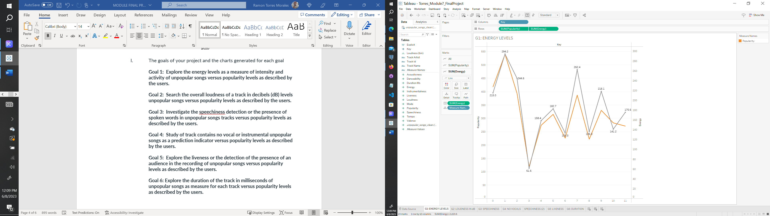

**Story 1: As depicted on the line chart, the energy levels as a measure of intensity and activity of unpopular songs as described by the users tend to move as the registered popularity trend. Unpopular songs with higher energy levels reached a higher popularity mark.**

**Goal 2: Search the overall loudness of a track in decibels (dB) levels unpopular songs versus popularity levels as described by the users.**

**CHART 2 Histogram chart of loudness of a track in decibels (dB) levels in unpopular songs tracks versus popularity levels for Spotify.**

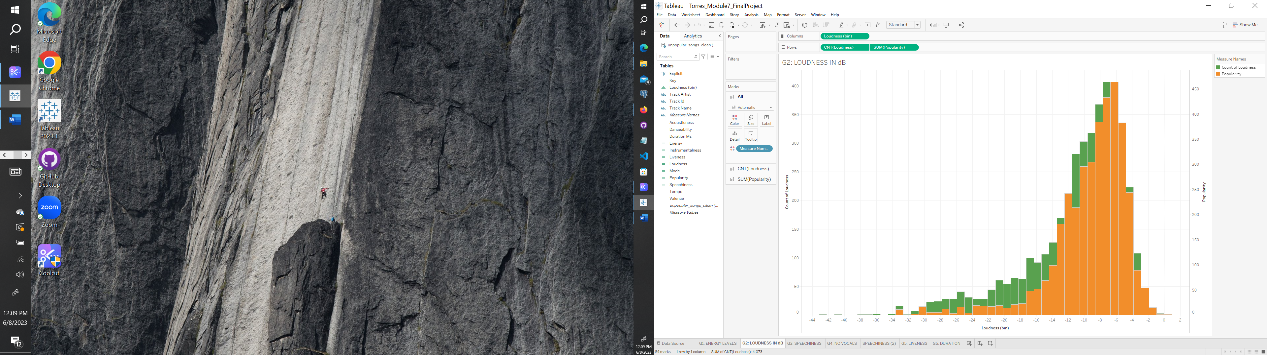

**Story 2: As illustrated on the histogram, the overall higher loudness of a track in decibels (dB) levels unpopular songs received a higher popularity measure. Songs with a count of loudness higher than 300, reached a higher popularity of over 350 level.**

**Goal 3: Investigate the speech detection or the presence of spoken words in unpopular songs tracks versus popularity levels as described by the users.**

**CHART 3 Packed Bubbles chart of the presence of spoken words in unpopular songs tracks versus popularity levels for Spotify.**

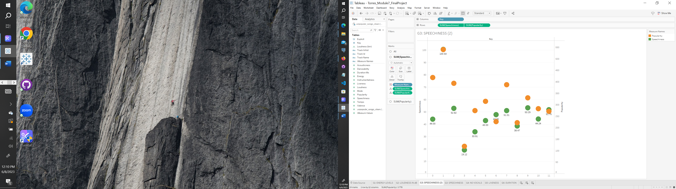

**CHART 3B Histogram chart of the presence of spoken words and instrumentals in unpopular songs tracks and versus popularity levels for Spotify.**

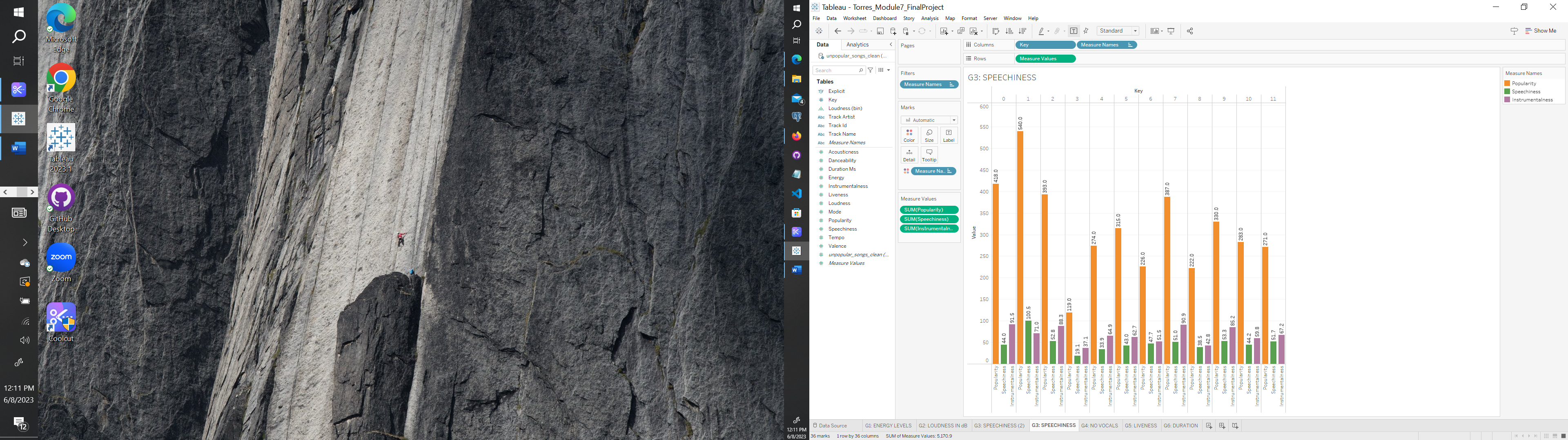

**Story 3: As depicted on the packed bubbles chart, the speech detection or the presence of spoken words in unpopular songs tracks with higher values reached a higher popularity level. For example, a speech detection of 100.54 reached a 540-popularity mark.**

**Goal 4: Study of track contains no vocal or instrumental unpopular songs as a prediction indicator versus popularity levels as described by the users.**

**CHART 4 Side-by-side circles chart of no vocal or instrumental in unpopular songs tracks versus popularity levels for Spotify.**

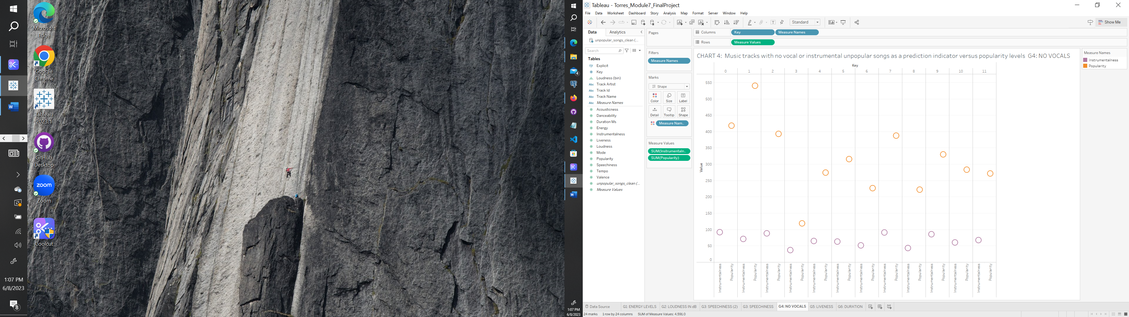

**CHART 4B Histogram chart of the presence of spoken words and instrumentals in unpopular songs tracks and versus popularity levels for Spotify.**



**Story 4: As depicted on side-by-side circles chart, track contains no vocal or instrumental unpopular songs showed low values and a range of popularity values from 150 to 550, mainly within the range of 200 to 450 values.**

**Goal 5: Explore the liveness or the detection of the presence of an audience in the recording of unpopular songs versus popularity levels as described by the users.**

**CHART 5 Horizontal bars chart of the liveness in unpopular songs tracks and versus popularity levels for Spotify.**

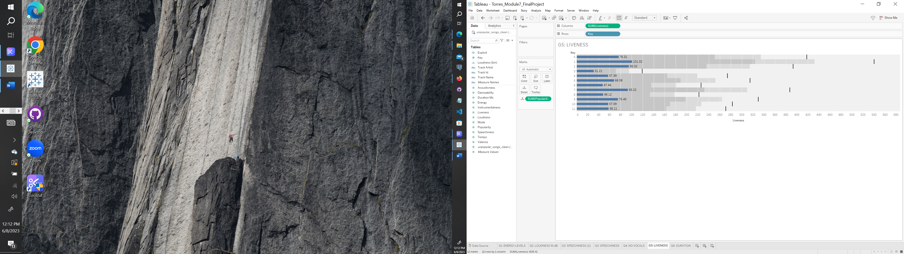

**Story 5: As portrayed on horizontal bars chart, the liveness, or the detection of the presence of an audience in the recording of unpopular songs with higher values reached a higher popularity level. For example, a value 101 liveness reached a 540-popularity level.**

**Goal 6: Explore the duration of the track in milliseconds of unpopular songs as measure for each track versus popularity levels as described by the users.**

**CHART 6 Scatter plot chart of the duration of the track in milliseconds of unpopular songs tracks versus popularity levels for Spotify.**

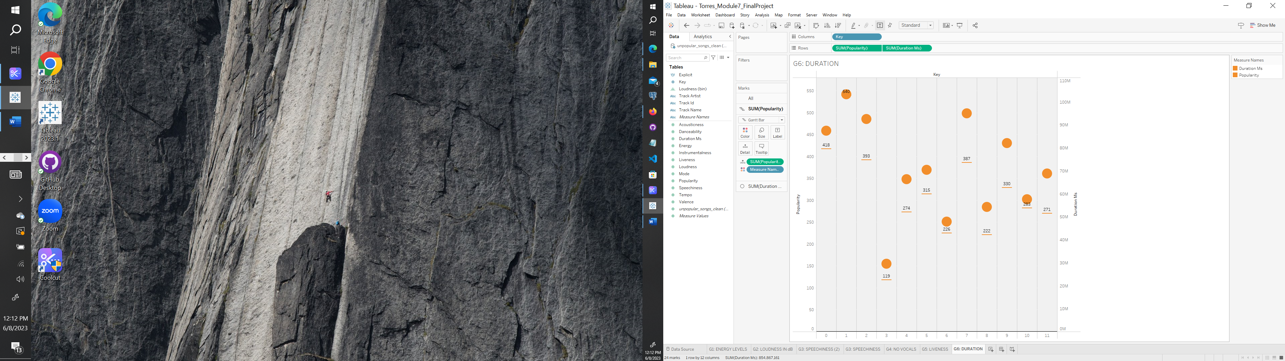

**Story 6: As represented on the scatter plot chart, higher duration of the track in milliseconds of unpopular songs showed a higher popularity level. For example, songs with duration of over 80ms reached popularity levels ranging from 330 to 540.**

* 1. Write the story from each chart that you generated.

**Storyboards were generated in Tableau for each goal and chart, respectively. The files were submitted as part of this final project, as required.**

**Story 1: As depicted on the line chart, the energy levels as a measure of intensity and activity of unpopular songs as described by the users tend to move as the registered popularity trend. Unpopular songs with higher energy levels reached a higher popularity mark.**

**Story 2: As illustrated on the histogram, the overall higher loudness of a track in decibels (dB) levels unpopular songs received a higher popularity measure. Songs with a count of loudness higher than 300, reached a higher popularity of over 350 level.**

**Story 3: As depicted on the packed bubbles chart, the speech detection or the presence of spoken words in unpopular songs tracks with higher values reached a higher popularity level. For example, a speech detection of 100.54 reached a 540-popularity mark.**

**Story 4: As depicted on side-by-side circles chart, track contains no vocal or instrumental unpopular songs showed low values and a range of popularity values from 150 to 550, mainly within the range of 200 to 450 values.**

**Story 5: As portrayed on horizontal bars chart, the liveness, or the detection of the presence of an audience in the recording of unpopular songs with higher values reached a higher popularity level. For example, a value 101 liveness reached a 540-popularity level.**

**Story 6: As represented on the scatter plot chart, higher duration of the track in milliseconds of unpopular songs showed a higher popularity level. For example, songs with duration of over 80ms reached popularity levels ranging from 330 to 540.**

* 1. Use Dashboards & storyboards to represent your charts and findings.

**The dashboard and storyboards were generated in Tableau, the files were submitted as part of this final project, as required. Storyboards 1 to 6, Dashboard #1 and Dashboard #2 on Tableau.**

* 1. Overall conclusion for your analysis

**A. Analysis Summary: The exploratory effort of the Spotify unpopular songs data set was analyzed. Several factors were identified to describe unpopular songs and compared against the popularity levels as described by the users. These factors drive customers away from listening. The main factors to analyzed unpopular songs included six factors. These included songs energy levels, loudness, speech or vocals, no vocals or instrumentals, liveness, and duration. These results will assist in determining which songs are not selected by music enthusiastic making these songs unlikeable. The use of these factors may enhance the customers interest AL algorithm, model interests and to generate recommended better evaluate the user experience. It will certainly keep them engage on the application a longer period. A brief story for each goal was presented describing the findings for each goal.**

**B. Conclusion: The exploratory methodology of this secondary data set has shown the relevance of evaluating the factors that influence the popularity levels of unpopular songs. After this initial and preliminary analysis, the indicators that showed more promise to be part of a prediction model includes energy levels, loudness, duration of the songs, and liveness, as shown on Dashboard #1 on Tableau. The instrumentals and vocals factors tend to show mixed popularity levels, Dashboard #2 on Tableau. These results further enhance the AI algorithm that puts together the recommended playlists and optimizes the user experience in Spotify. This exercise may be applicable to the same analysis of other music platforms, like Amazon Music, Pandora, Jango Music and others.**

**C. Recommendations: Further exploratory studies of secondary data and web mining content are highly recommended. A correlational analysis should be performed to determine the factors that influence the popularity of unpopular songs available on Spotify. Additional data sets may be obtained to develop a regression analysis and generate an AI prediction model on the user acceptance and minimize the availability of unpopular songs.**

* 1. Zip the following files and submit them to this final project assignment. **Attached files.**
     1. Tableau files (with. twbx extensions),
     2. Excel files, and
     3. MS Word document from step 8